GARAGE MANAGEMENT

**College Name:** Sri Krishna Adithya College of Arts and Science

**College Code:** bruag

**TEAM ID:** NM2025TMID22245

**TEAM MEMBERS:**  4

**Team Leader Name:**  CELINE FRANCINA M

**Email:** [23bsai113celinefrancinam@skacas.ac.in](mailto:23bsai113celinefrancinam@skacas.ac.in)

**Team Member1:** GAYATHRI G

**Email:**  [23bsai115gayathrig@skacas.ac.in](mailto:23bsai115gayathrig@skacas.ac.in)

**Team Member2:**  HARINI S

**Email:**  [23bsai117harinis@skacas.ac.in](mailto:23bsai117harinis@skacas.ac.in)

**Team Member3:** VAIBHAVLAKSHMI S P

**Email:** [23bsai162vaibhavlakshmisp@skacas.ac.in](mailto:23bsai162vaibhavlakshmisp@skacas.ac.in)

**1.INTRODUCTION**

**1.1 Project Overview**

The Garage Management System is a Salesforce-based application designed to simplify and automate the operations of vehicle service centers. It manages customer details, appointments, service records, billing information, and customer feedback with efficiency and transparency. Automation features such as flows, approval processes, and email alerts ensure seamless scheduling, timely updates, and improved customer satisfaction.

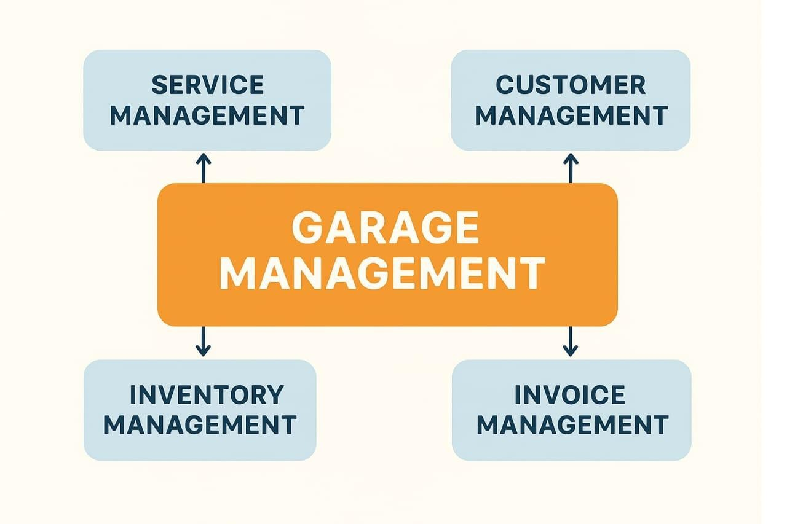

**1.2 Purpose**  
The main objective of the project is to enable organizations to efficiently manage garage operations, including customer details, appointments, service records, billing, and feedback. It reduces manual intervention, improves accuracy in service tracking and billing, and ensures better communication and customer satisfaction.

**DEVELOPMENT PHASE**

**Creating Developer Account:**

By using this URL [**- https://www.salesforce.com/form/developer-signup/?d=pb**](https://www.salesforce.com/form/developer-signup/?d=pb)

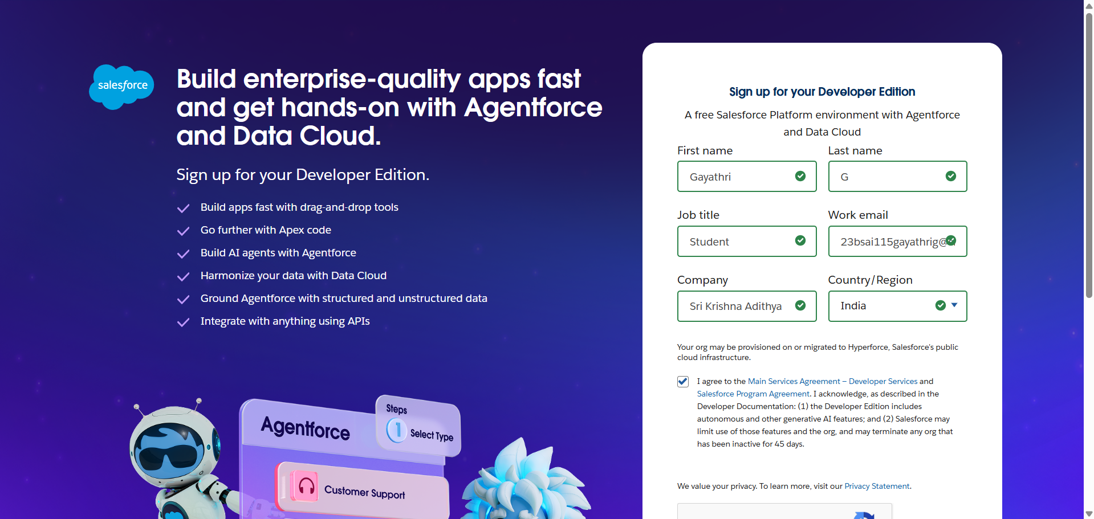

* Created objects: Customer details, appointment, service record, billing details and feedback

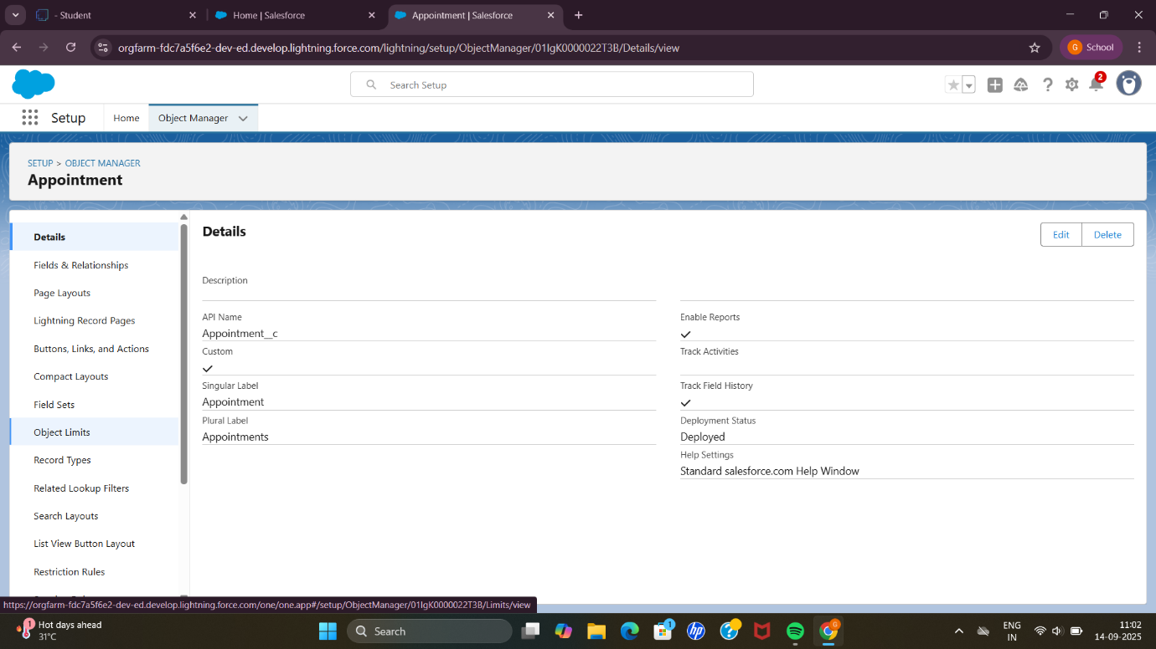

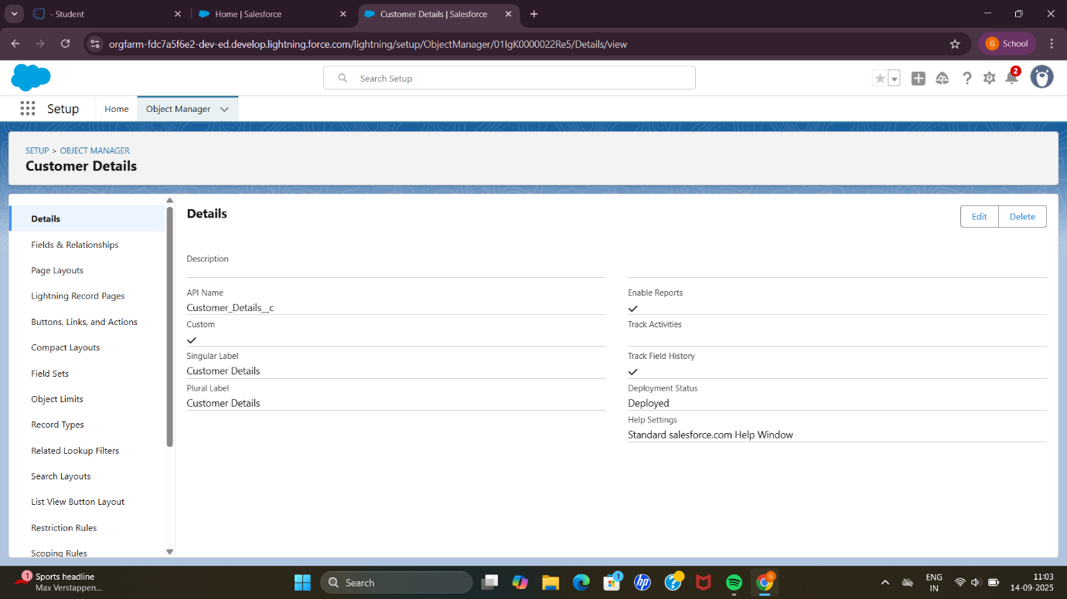

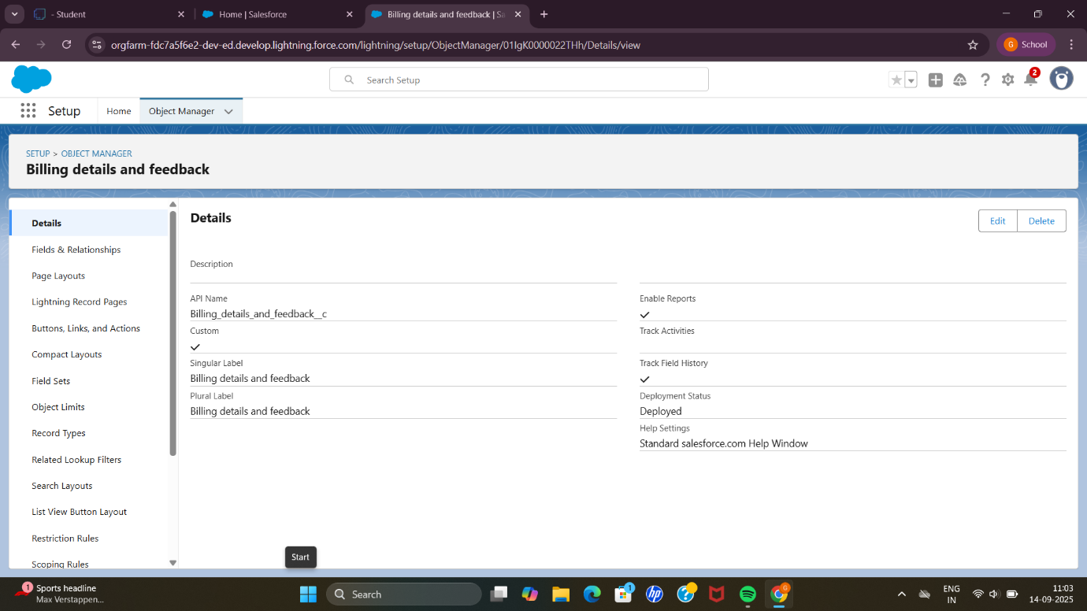

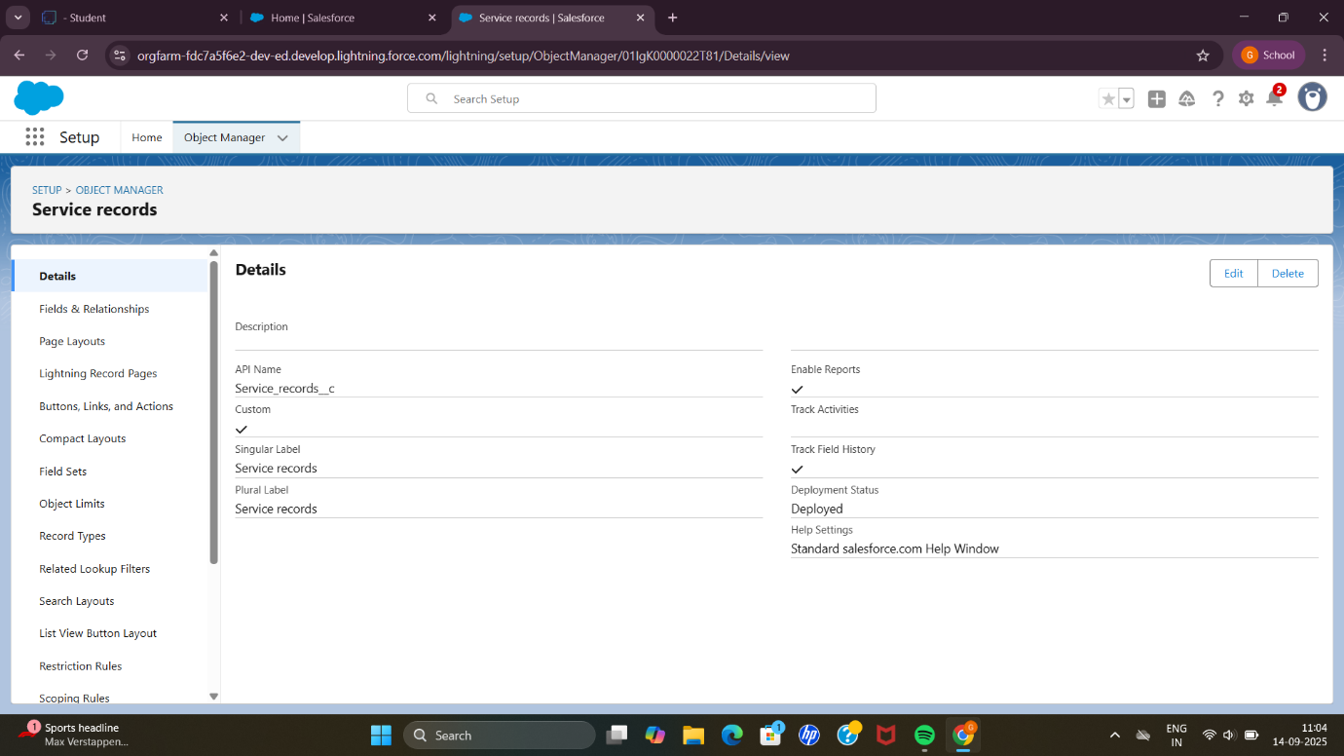

* Configured fields and relationships

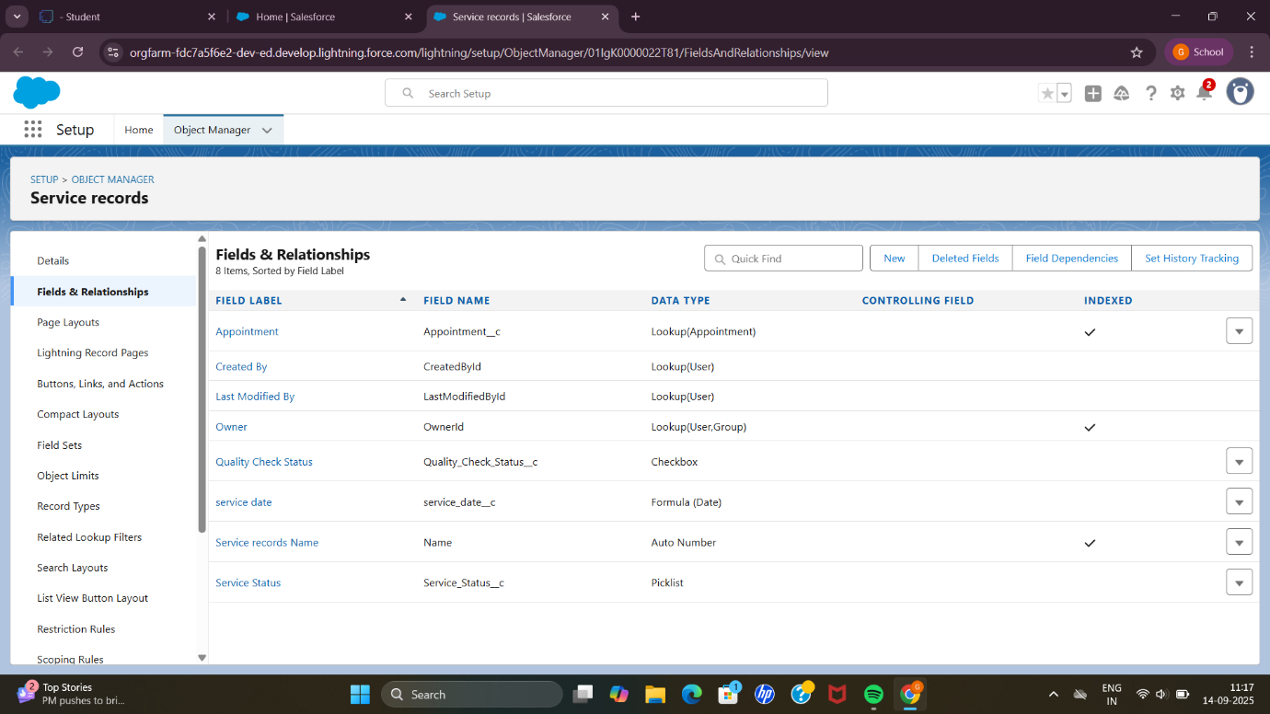

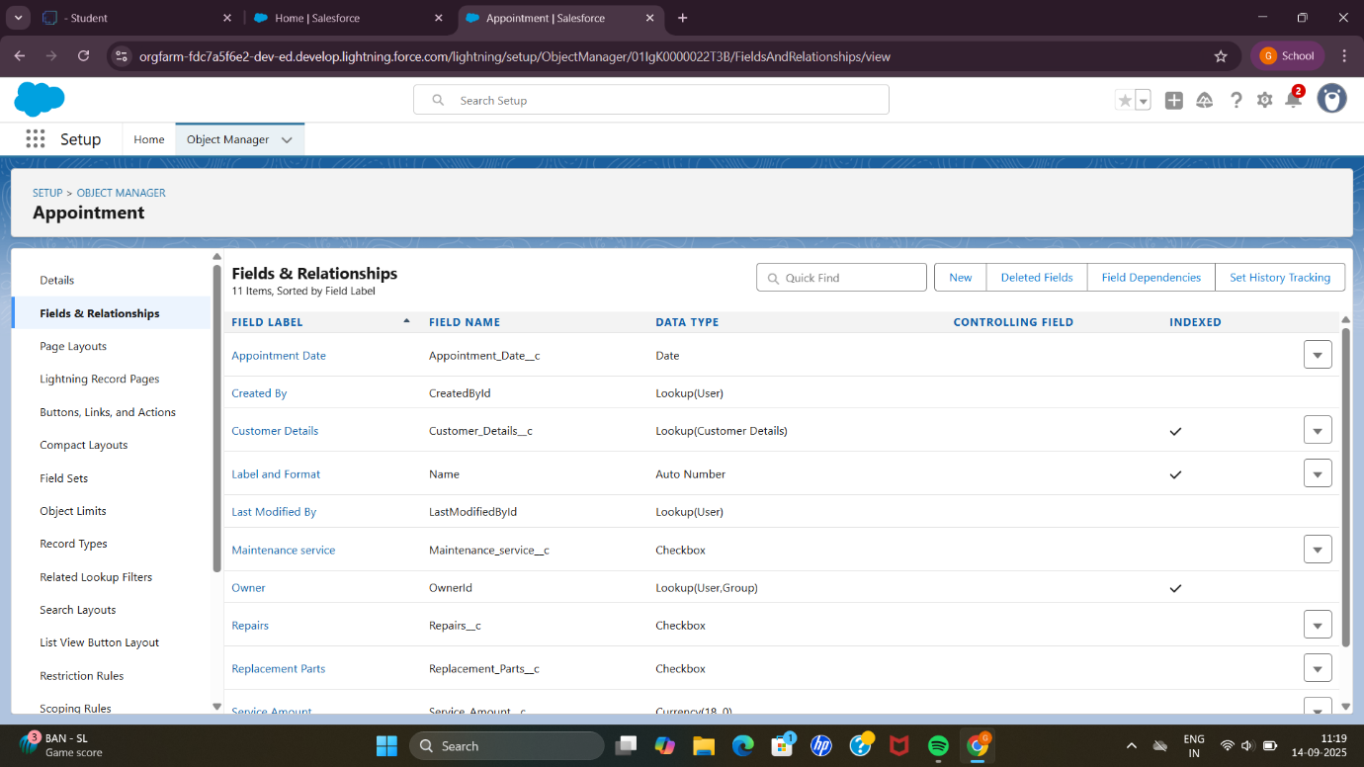

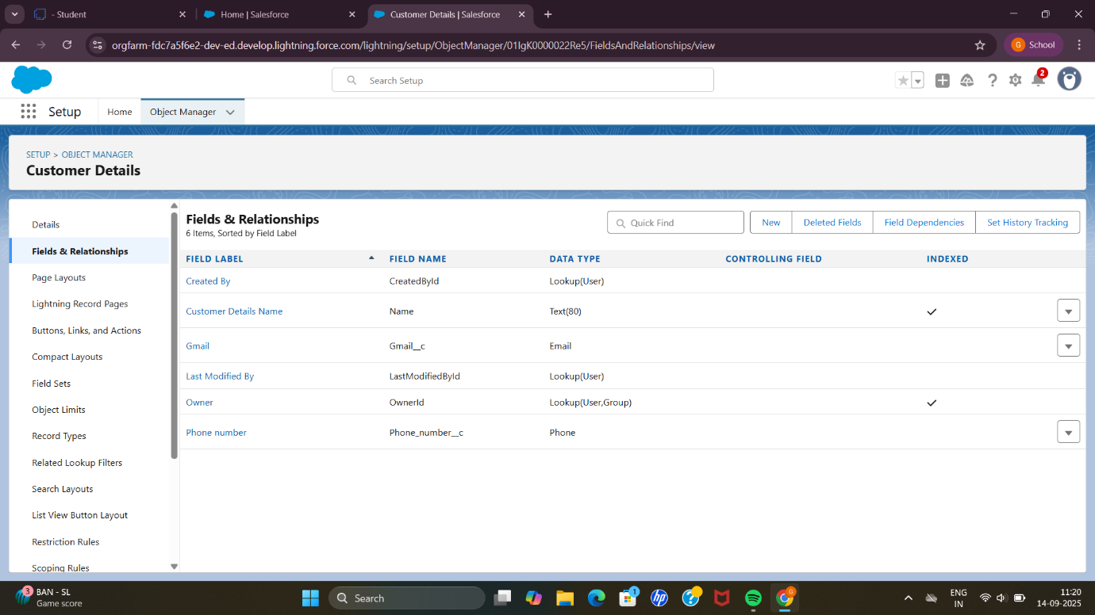

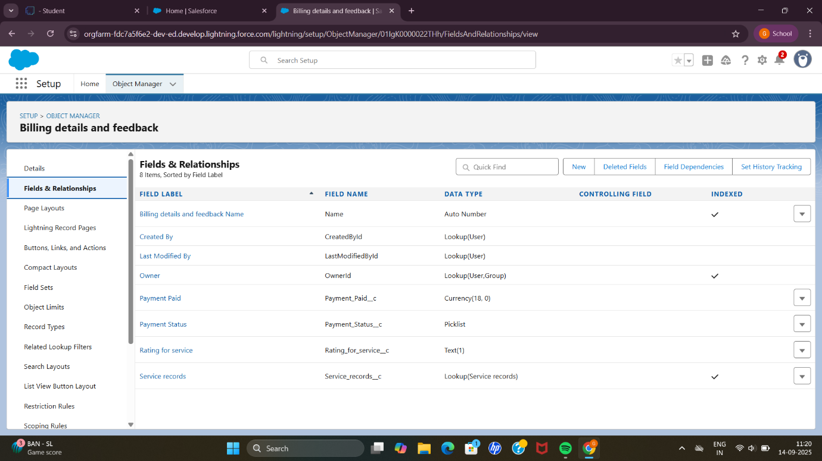

* Developed Lightning App with relevant tabs

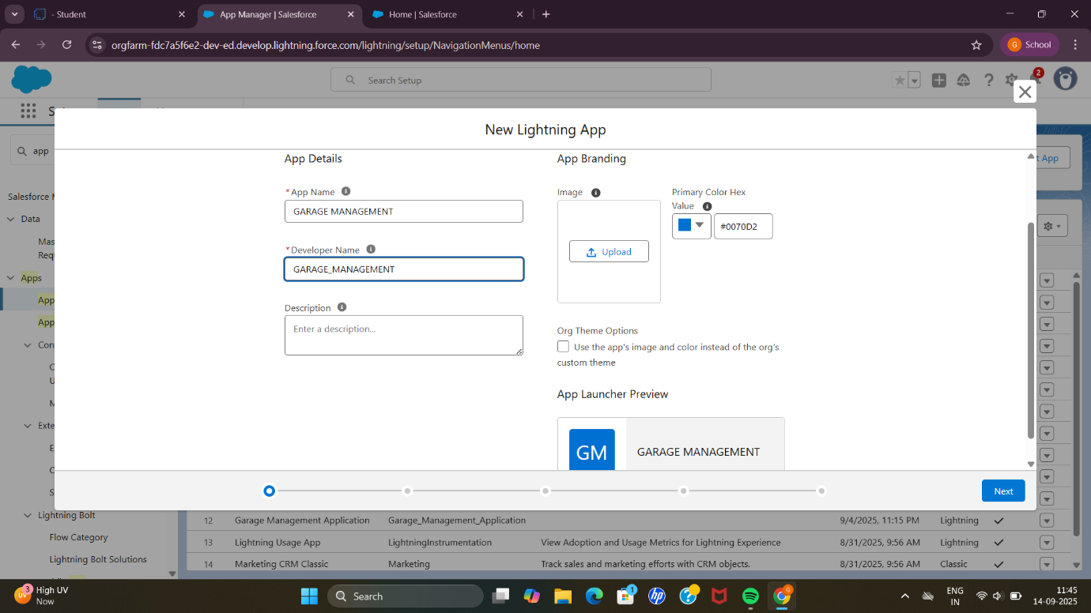

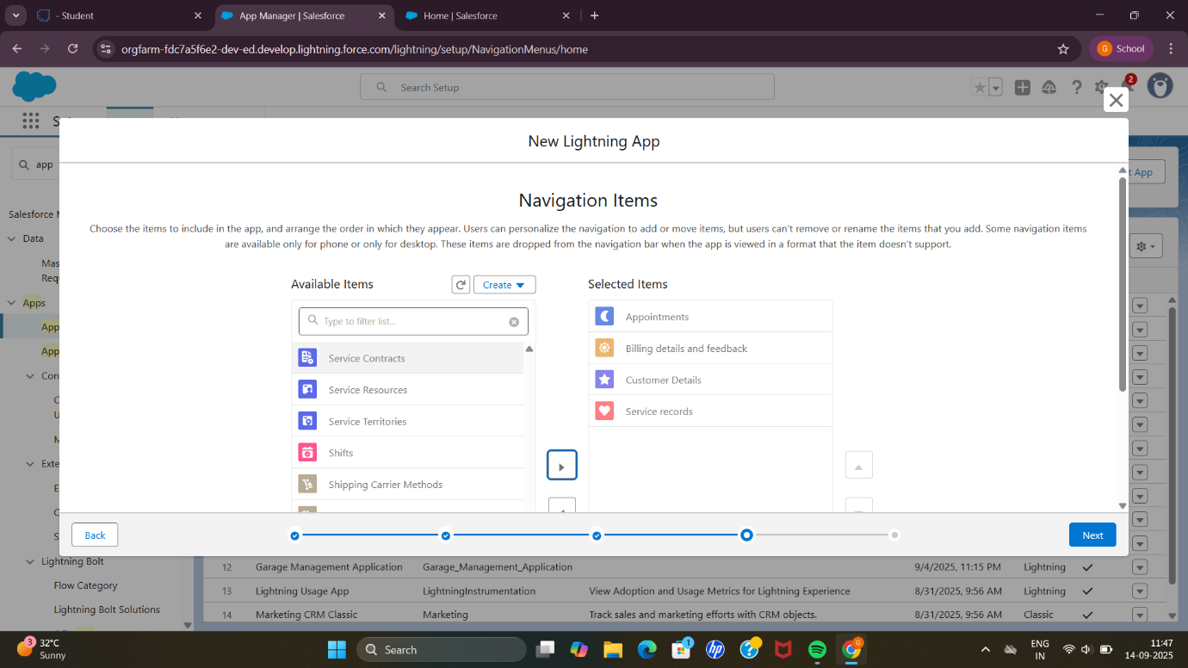

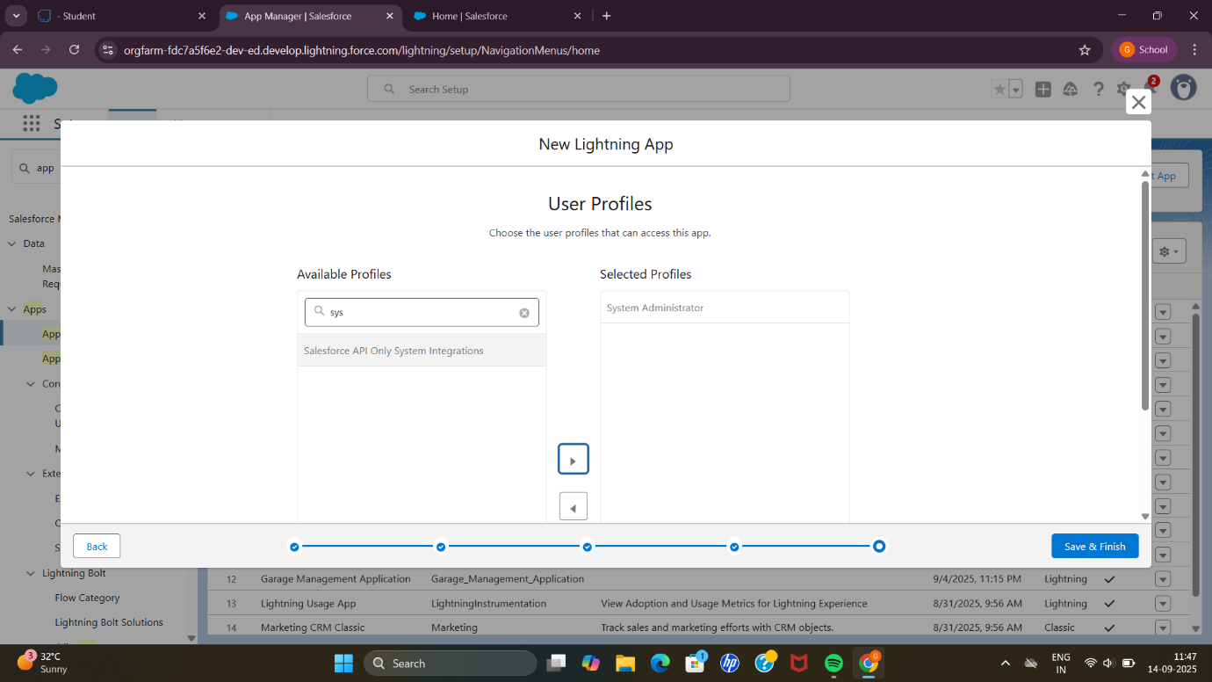

* Implemented Flows for billing details and feedback, Service records.

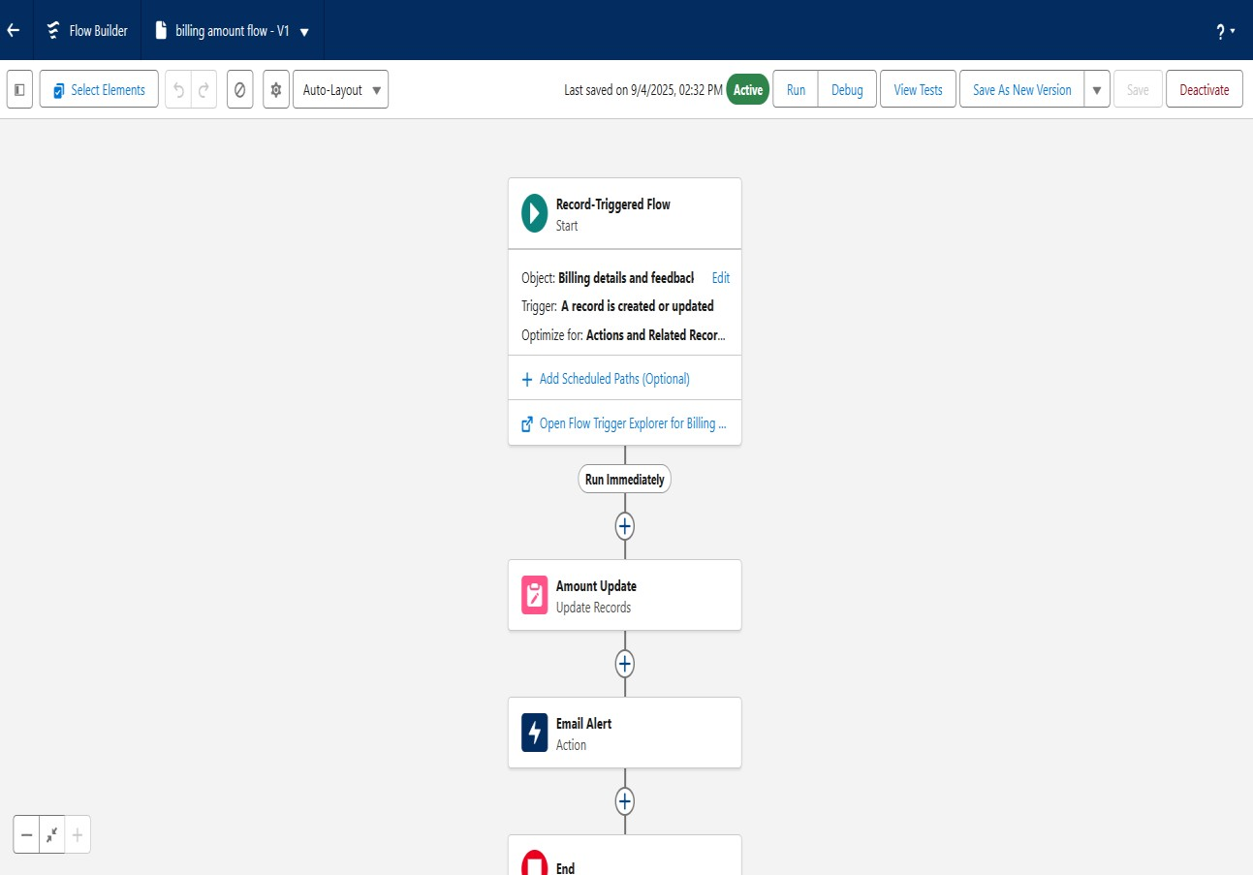

* To create a validation rule for billing and feedback, appointment objects.

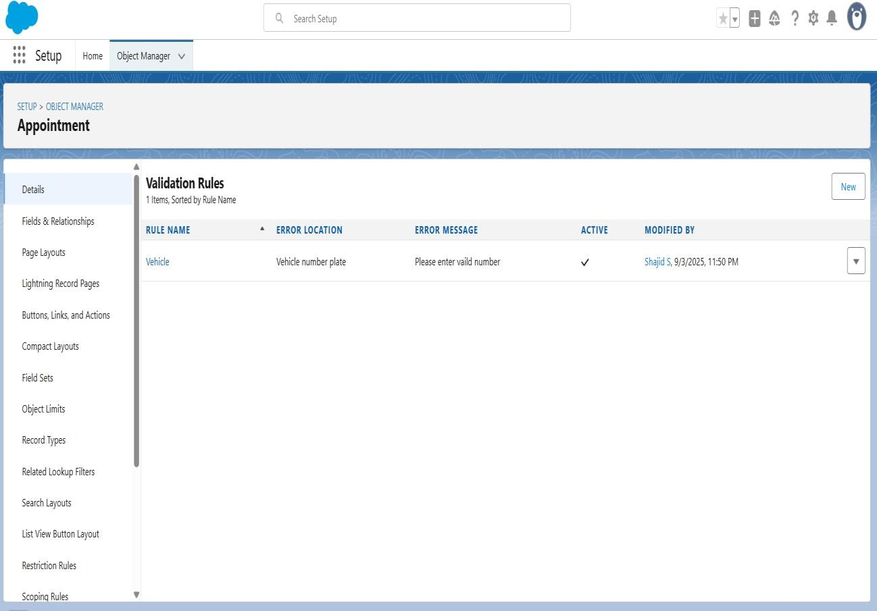

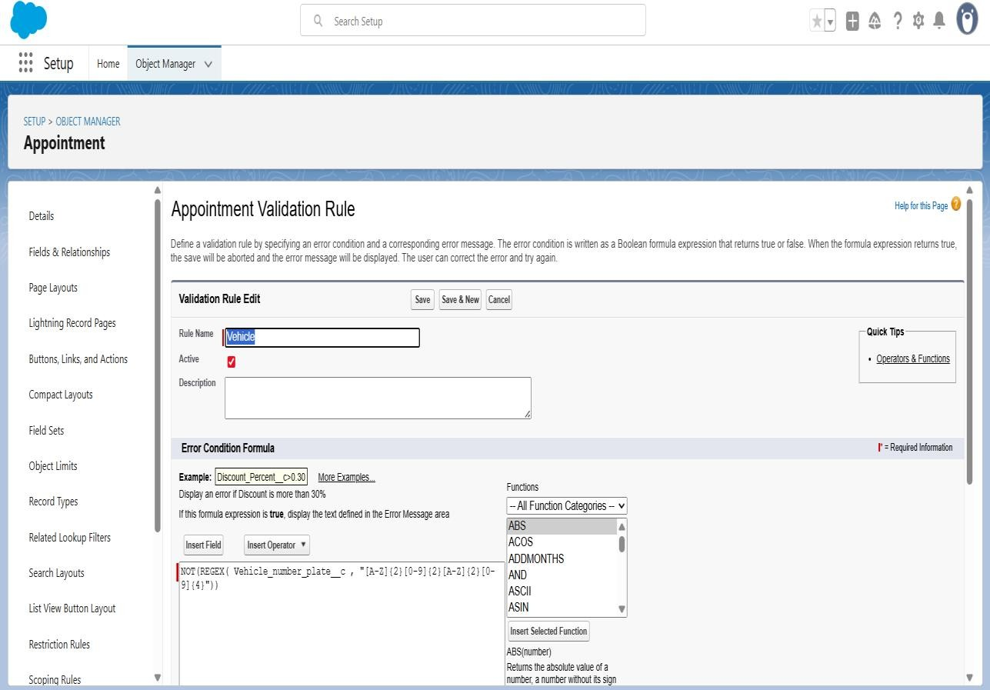

* Added Apex trigger Amount Distribution Handler.

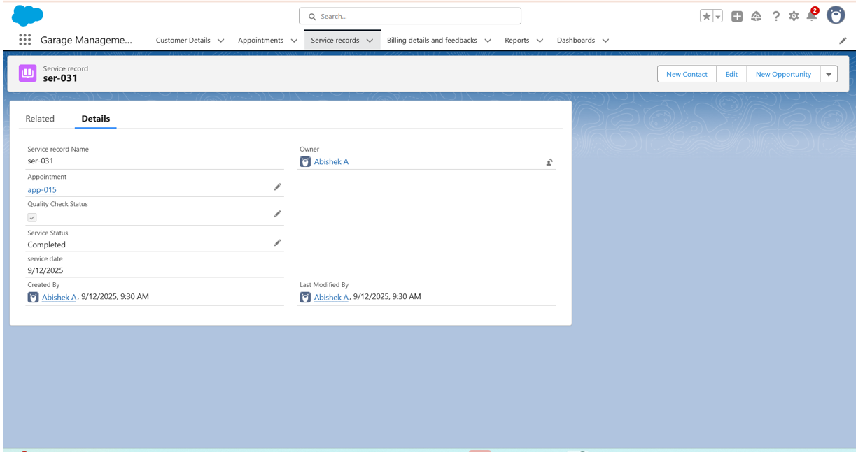

* Scheduled notification reminder emails using Apex class.

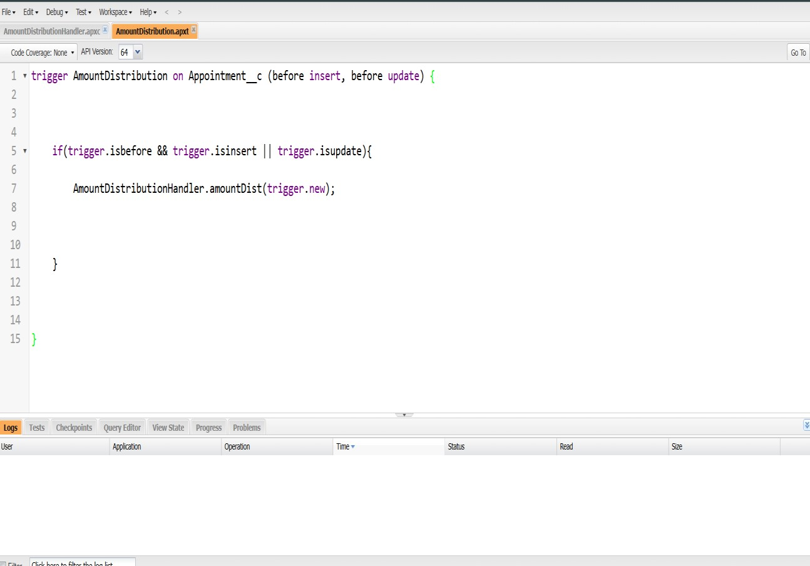

* Apex Trigger

Create an Apex Trigger

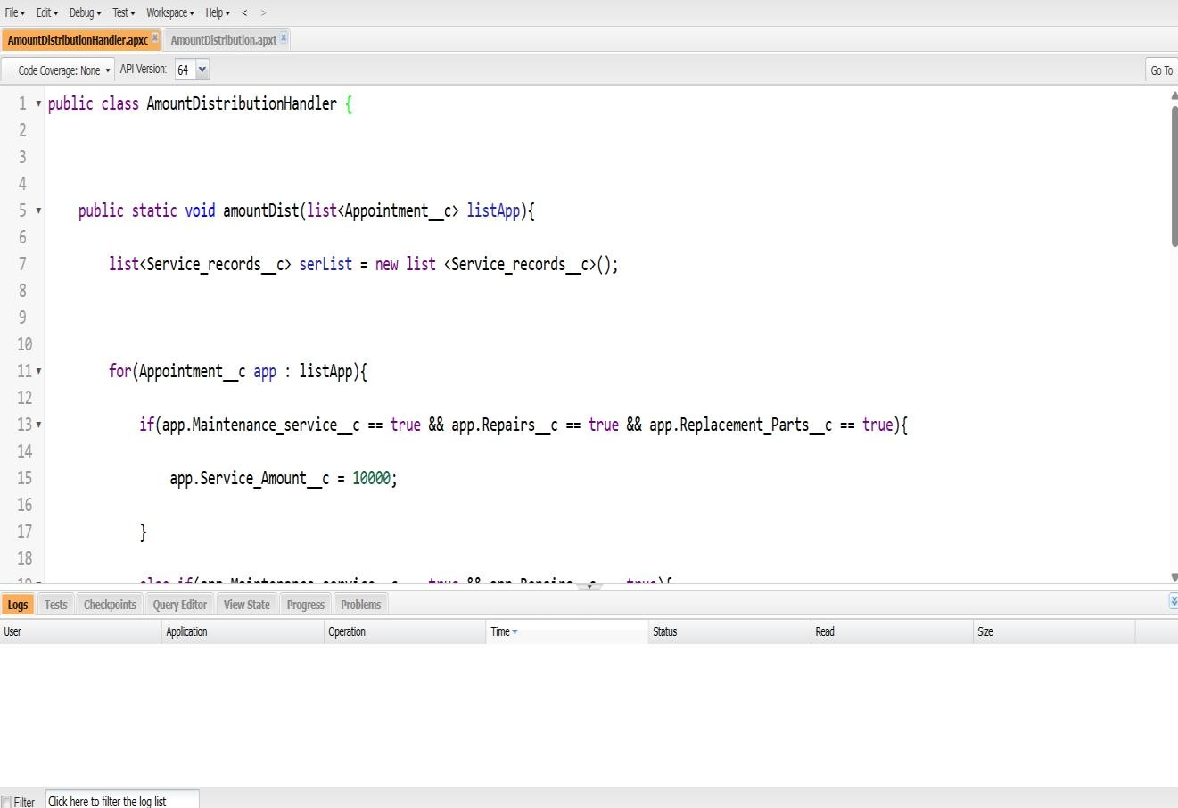

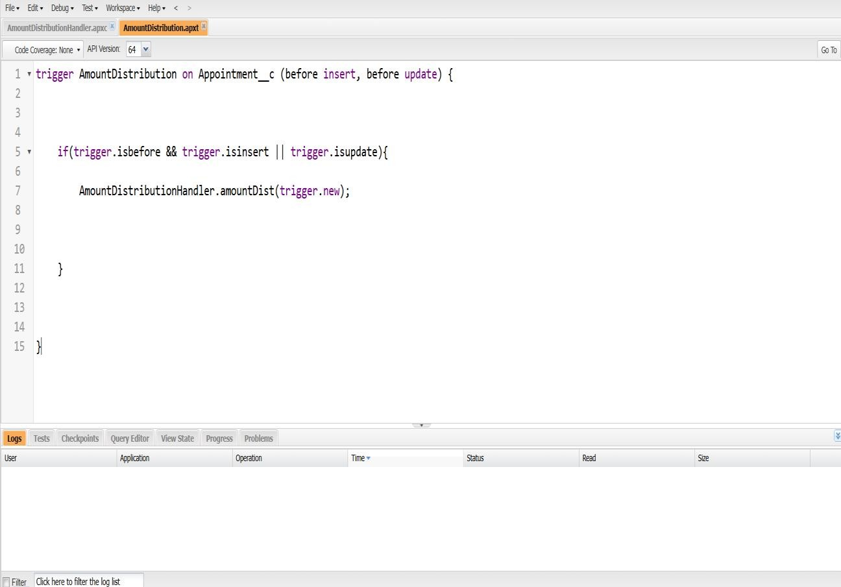

* Create an Apex Handler class



* Schedule Apex class

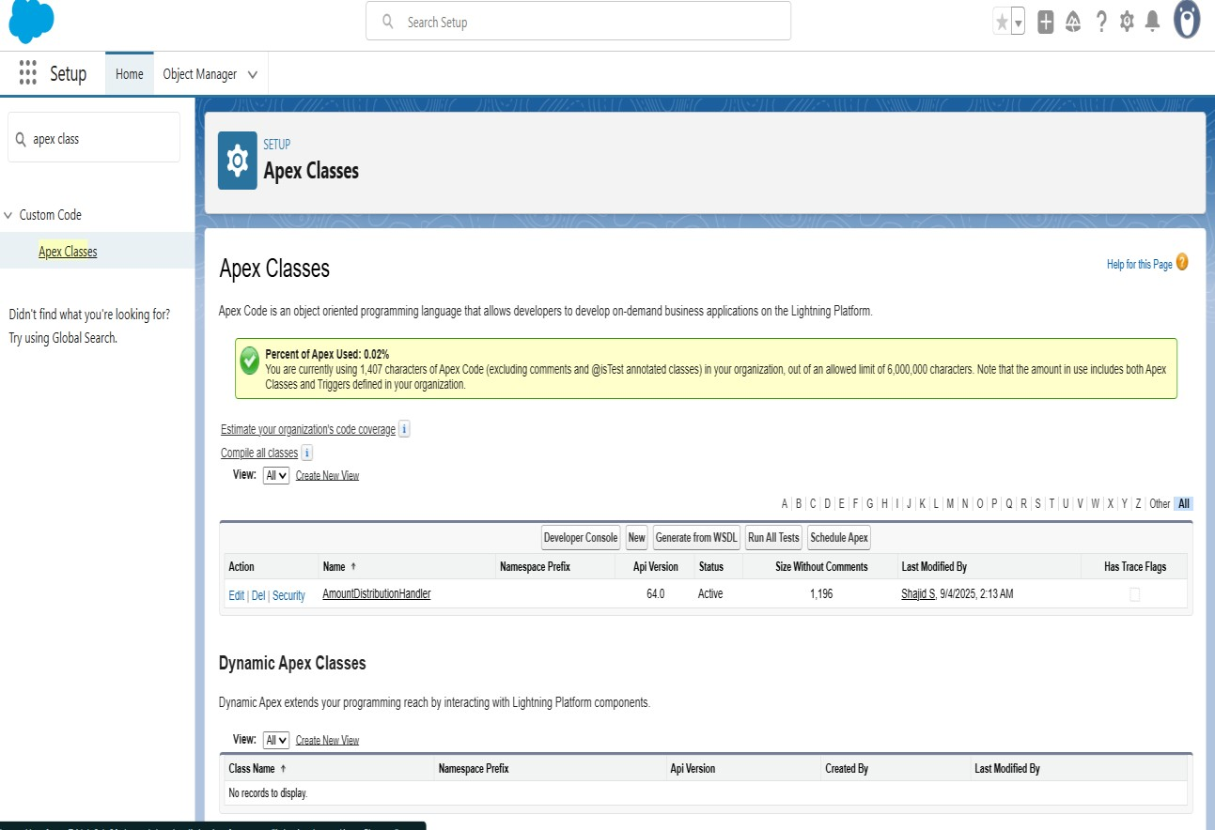

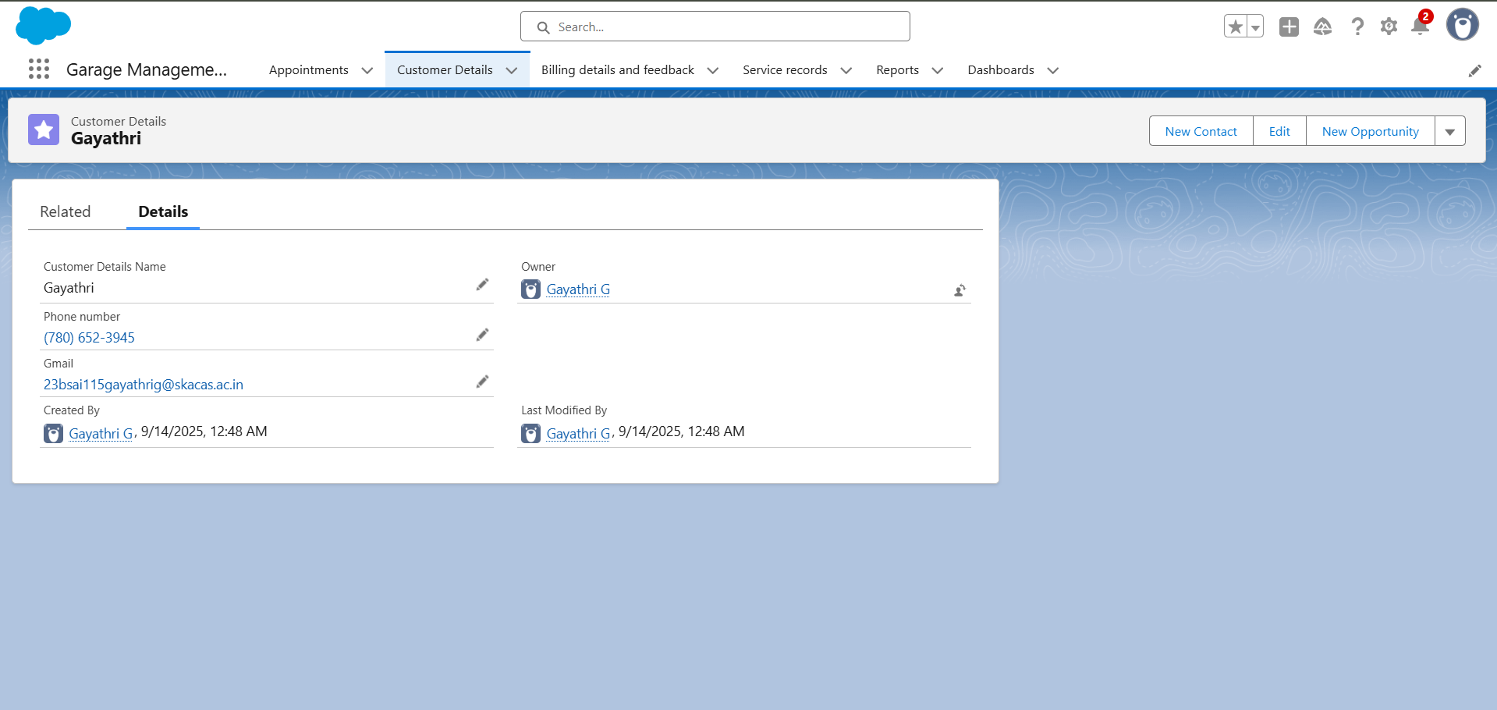

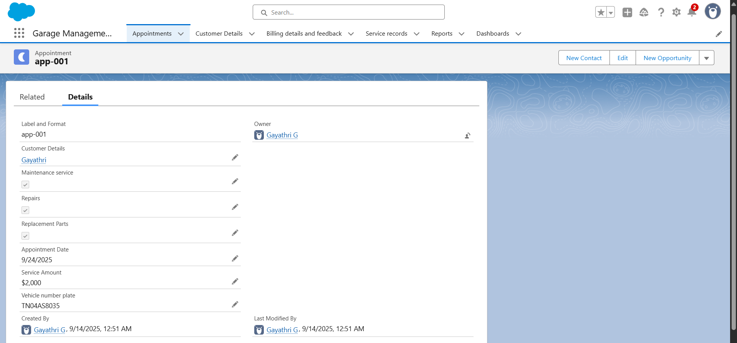

FUNCTIONAL AND PERFORMANCE TESTING

**Performance Testing**

● Trigger validation by entering duplicate appointment name.

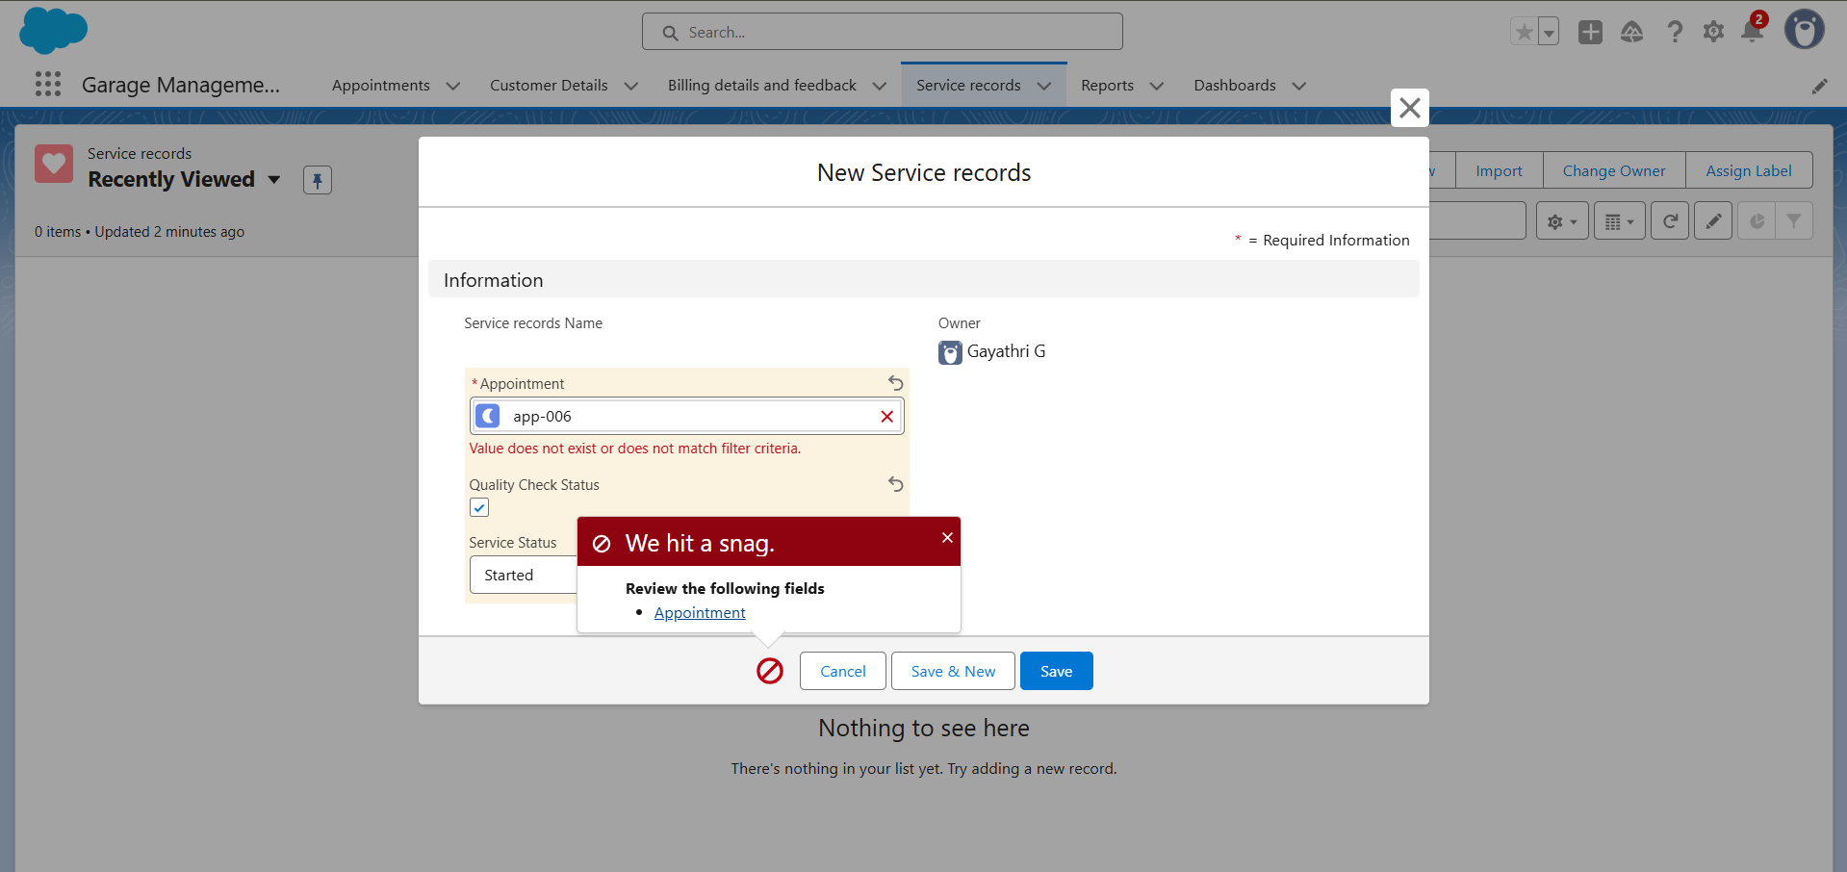

* Validation Rule checking

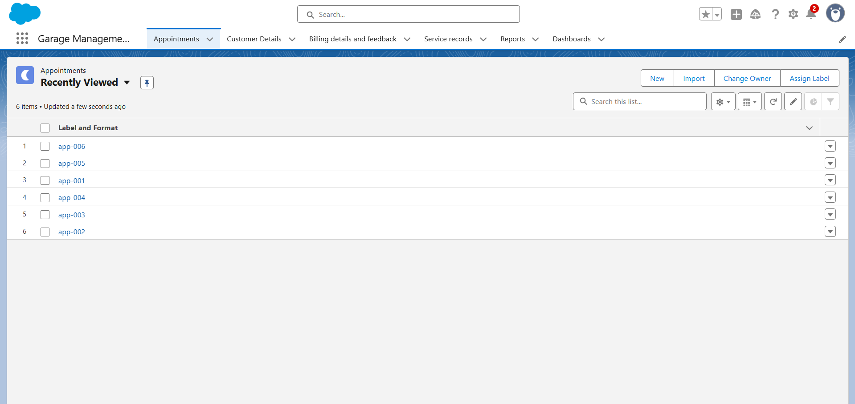

RESULTS

**Output Screenshots**

• Tabs for Customer details, Appointment, Service records, Billing details and feedback.

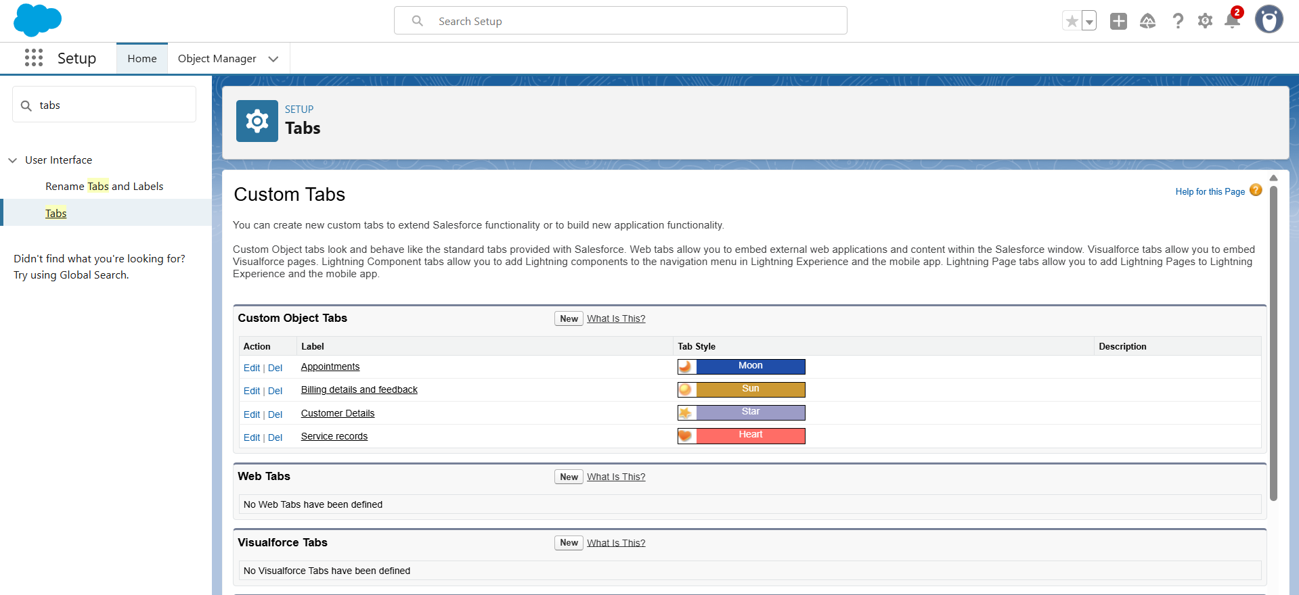

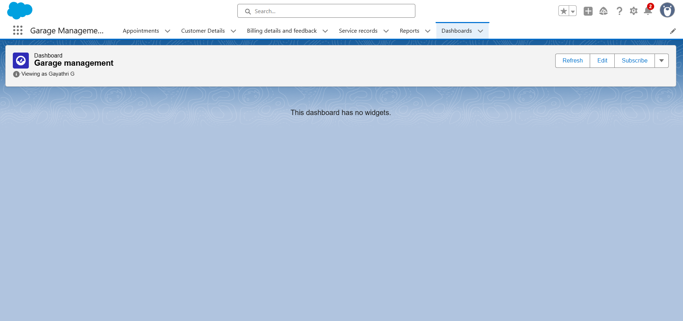

**ADVANTAGES & DISADVANTAGES**

**Advantages**

* Centralized data storage for customer, vehicle, and service details.
* Better customer service with service reminders and history tracking.
* Automation of job cards, invoices, and service records.
* Integration with Salesforce CRM for a 360° customer view.
* Effective spare parts and inventory management.
* Detailed reports and analytics for business decisions.
* Scalable and customizable for any size of garage.

**Disadvantages**

* Complex setup and requires proper Salesforce configuration.
* High cost of Salesforce licensing and maintenance.
* Needs stable internet connection for smooth operation.
* Learning curve for staff with limited technical knowledge.
* Customization effort required to fit unique workflows.
* Data security and privacy concerns in cloud storage.

**CONCLUSION**

The Garage Management System successfully streamlines the operations of leasing through a structured, automated Salesforce application. It improves efficiency, communication, and data accuracy for both admins and customers.